**Visualization Tool for Electric Vehicle Charge and Range Analysis**

1. INTRODUCTION
   1. Overview:

A vehicle that can be powered by an electric motor that draws electricity from a battery and is capable of being charged from an external source and have an electric motor instead of an internal combustion engine.

The new EV’s are combined Electrical storage and propulsion systems with electronic sensors, controls, and actuators, integrated closely with software, secure data transfer to form a comprehensive transportation solution**.**

* 1. Purpose:

## Electric travelling appears to dominate the transport sector in the near future due to the needed transition from internal combustion vehicles (ICV) towards Electric Vehicles (EV) to tackle urban pollution.

1. PROBLEM DEFINITION & DESIGN THINKING:

* 1. Empathy Map



* 1. IDEATION AND BRAINSTORMING MAP:

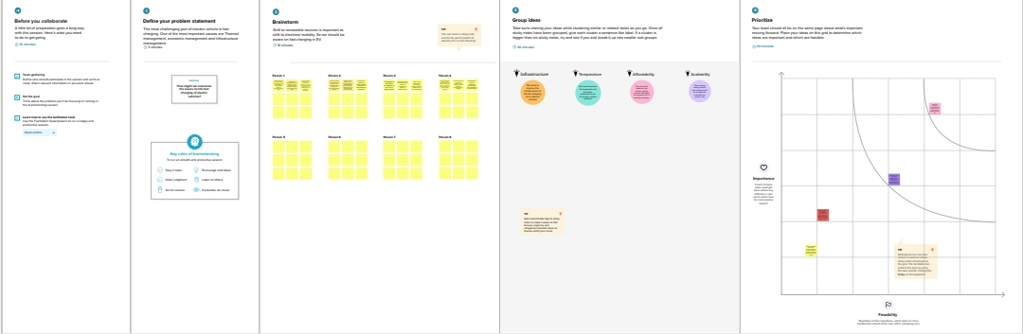

3 RESULT





1. ADVANTAGES AND DISADVANTAGES

Advantages:

* **Eco-friendly**

**\* Renewable energy source**

**\*Less noise and smoother motion**

**\* Cost-effective**

**\*Low maintenance**

**\*Government support**

Disadvantages:

* **High initial cost**

**\*Charging station limitations**

**\*Recharging takes time**

**\*Limited options**

**\*Less driving range**

1. **APPLICATION**

Electric vehicles are the key technology to decarbonise road transport, a sector that accounts for 16% of global emissions. Recent years have seen exponential growth in the sale of electric vehicles together with improved range, wider model availability and increased performance.

Sales in developing and emerging countries have been slow due to higher purchase costs and a lack of charging infrastructure availability.

1. CONCLUSION

The basic conclusion is that when it comes to climate change and air quality, **electric cars** are clearly preferable to petrol or diesel cars. The electricity source in the case of EVs is equally significant. If energy is generated by means of environmental destruction such as coal-fired power stations, as is often the case in developing countries, it essentially contradicts the environmental benefits of electric cars.